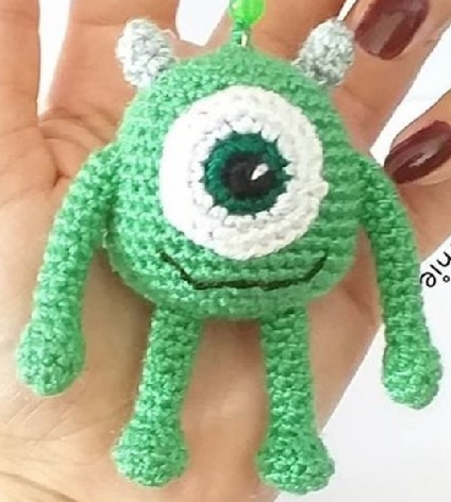**Mike Wazowski Crochet Pattern**

***\*2mm Hook\****

**Head & Body;**

*Light Green*  
R1: SC6 in MR [6]

R2: Inc x6 [12]

R3: (SC, Inc) x6 [18]

R4: (SC2, Inc) x6 [24]

R5: (SC3, Inc) x6 [30]

R6-7: SC around [30]

R8: (SC4, Inc) x6 [36]

R9-16: SC around [36]

R17: (SC4, Dec) x6 [30]

R18: (SC3, Dec) x6 [24]

R19: (SC2, Dec) x6 [18]

**Eye;**

*Black*

R1: SC6 in MR [6]

*Dark green*

R2: Inc x6 [12]

*White*

R3: (SC, Inc) x6 [18]

R4: (SC2, Inc) x6 [24]

Fasten off.

**Horns (Make 2);**

*Gray*

R1: SC4 in MR [4]

R2: (SC, Inc) x2 [6]

R3: SC6 around [6]  
Fasten off.

R20: (SC, Dec) x6 [12]

R21: Dec x6 [6]

Fasten off.

**Arms (Make 2);**

*Light Green*  
R1: SC6 in MR [6]

R2: Inc x6 [12]

R3: SC around [12]

R4: Dec x6 [6]

R5-15: SC around [6]

Fasten off.

**Legs (Make 2);**

*Light Green*  
R1: SC6 in MR [6]

R2: Inc x6 [12]

R3: SC around [12]

R4: Dec x6 [6]

R5-12: SC around [6]

Fasten off.